# **Keno Test cases execution options**

# Option 1: via Direct Module

## Step 1: Select “Module_TC” within the automation framework

## Step 2: Right click & select “Run as” - > “Run Configurations”

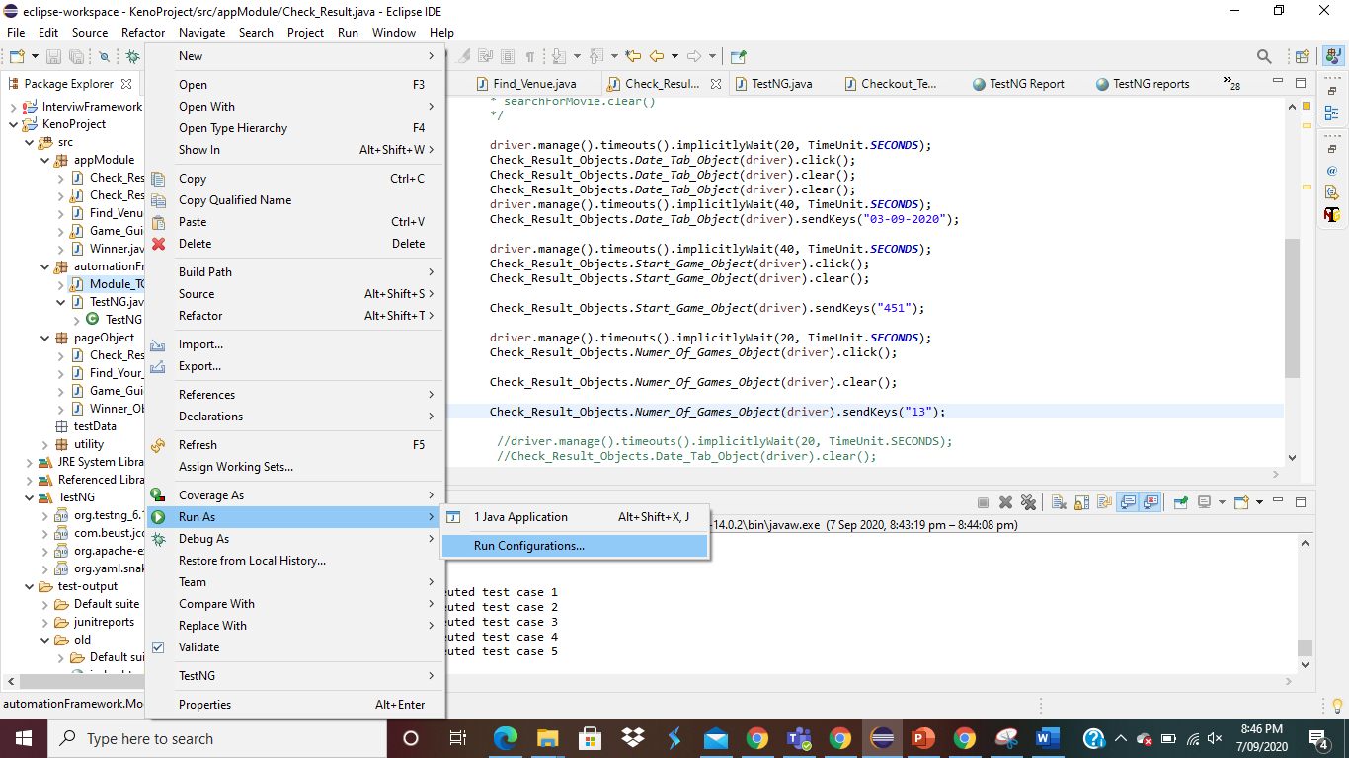

## Step 3 – “Run java application” window will open for the selected module

## Step 4 – Click “Run”

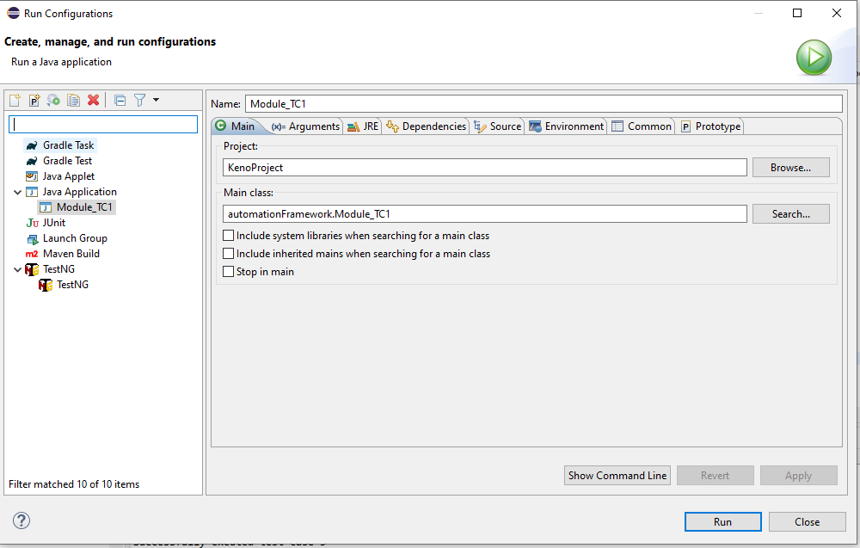

# Result Output –

Note: I have included extra print command to show the execution status of each test case

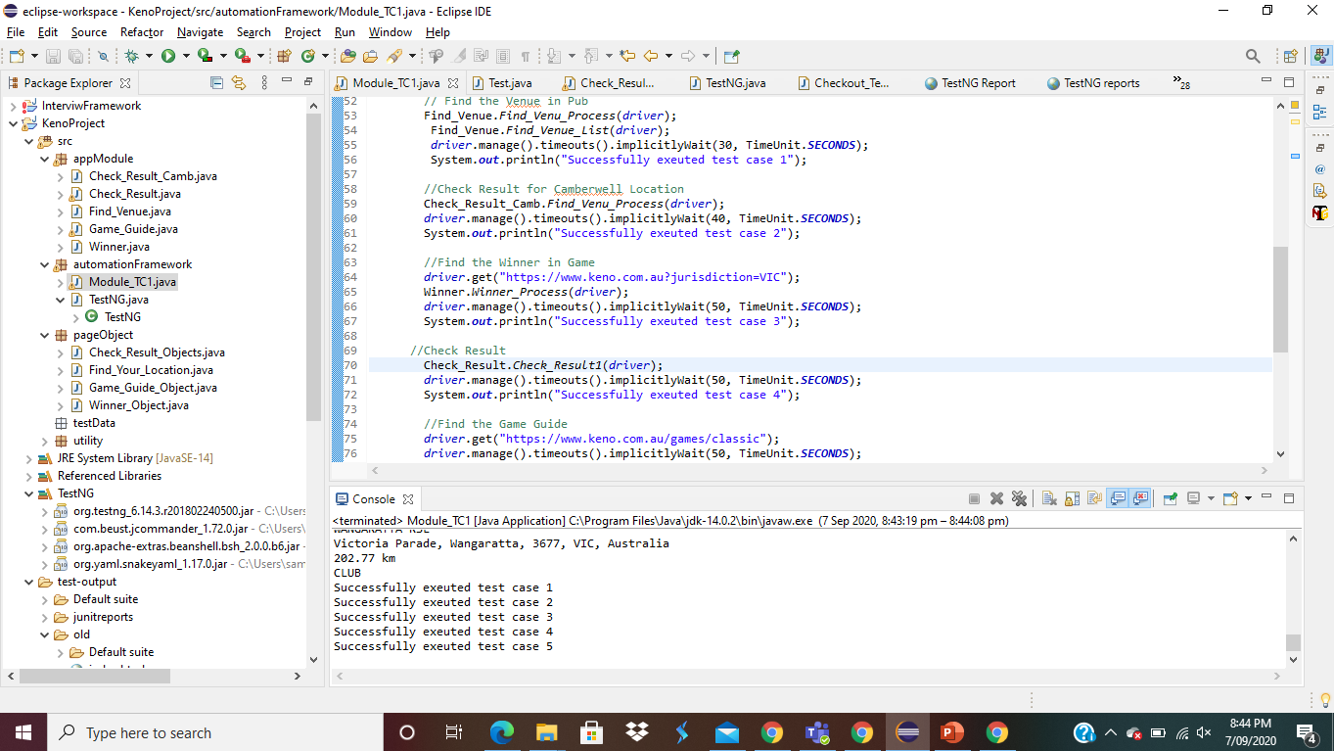

# Option 2- via TestNg framework

## Step 1 – Select “TestNG” within the project framework

## Step 2: Right click & select “Run as” - > “TestNG Test”

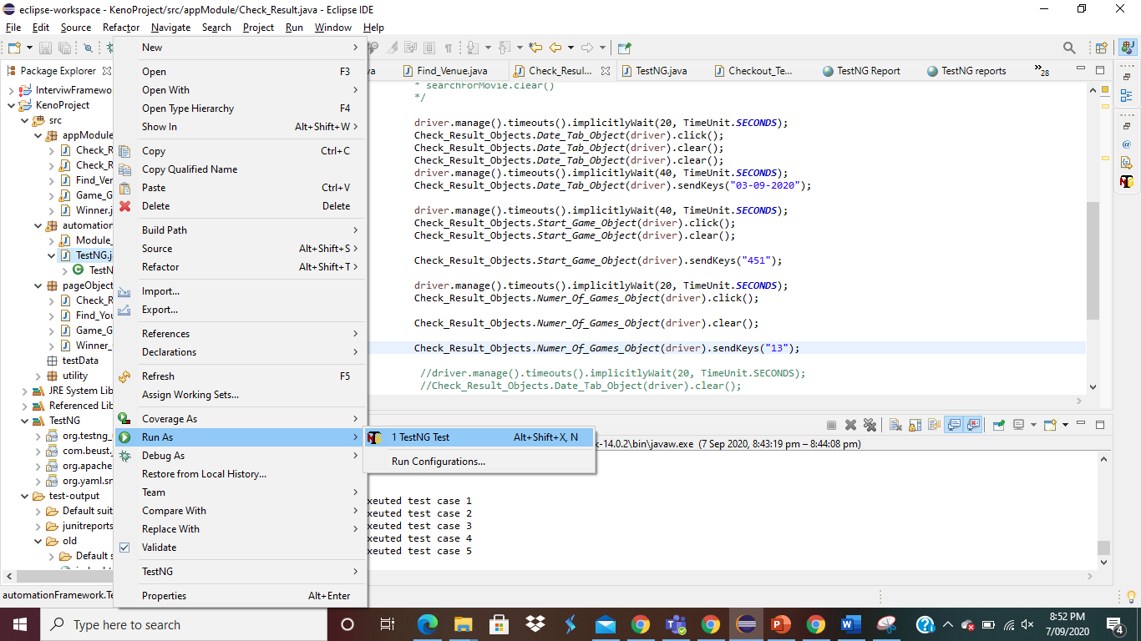

# Result Output –

Note: I have included extra print command to show the execution status of each test case

Print screen after TestNG execution

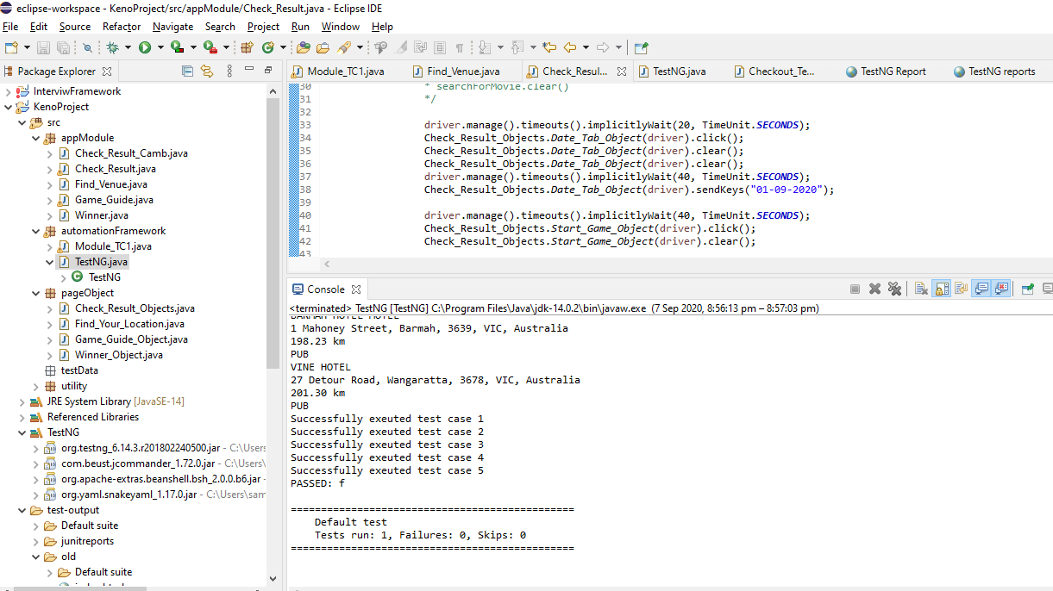

Emailable-report can be also accessed via test-output suite

